|  |
| --- |
|  |
| **LMS Attendance**  **System Documentation** |
| |  |  |  | | --- | --- | --- | | Group 10 & 4 |  | January 2024 | |

**Table of Contents**

**1.** **Introduction** 2

**1.1.** **Overview** 2

**1.2.** **Documentation Purpose** 2

**1.3.** **Challenges** 2

**1.4.** **Proposed Solution** 3

**1.5.** **Objectives** 3

**2.** **Benefits** 4

**3.** **System Architecture** 4

**3.1.** **Components** 4

**3.2.** **Interactions** 4

**4.** **System Visual** 5

**5.** **System Diagrams** 6

**5.1.** **Use case Diagrams.** 6

**5.2.** **Activity Diagrams** 7

**3.4.** **Class Diagrams** 11

**3.5.** **Entity-Relationship Diagram** 12

## **Introduction**

## **Overview**

The Geeks4Learning Attendance System (LMS) is your tool for easy attendance tracking. Developed using microservices, this system is designed to simplify and automate the attendance process for our Geeks (students). The system also assists the trainers and administrators to keep up to date with the factors that could affect the Geeks’ progress. This brief overview will help you understand why we have this system and what it can do.

## **Documentation Purpose**

This guide exists to show Geeks, trainers, and admins how to use the Geeks4Learning Attendance System. The goal is to make attendance tracking simple and hassle-free.

## **Challenges**

Attendance is currently tracked through a Biometrics system that serves its intended purpose, but its efficiency is compromised. Under the current Biometrics system, administrators face operational challenges. Specifically:

* **Manual Spreadsheet Management**: Despite the capabilities of the Biometrics system, administrators must engage in a manual process. They need to request attendance spreadsheets from the IT department, review the data, make updates to account for learners on leave, and subsequently submit the updated information to the HR department.
* **Non-G4L System Compliance:** The Biometrics system, while meeting some requirements, falls short of being a fully compliant Geeks4Learning (G4L) system. An important example is the lack of seamless communication between the leave system and the attendance system. The involvement of a third-party system hinders the archival of critical data.

## **Proposed Solution**

An Attendance system must be developed specifically for G4L a system which will have all the rules and policies that G4L have.

* The purpose of the G4L attendance system is to keep track of the presence and/or absence of Geeks in the workplace.
* An attendance system is typically used by organizations to monitor the attendance of their employees (who are the Geeks in our case) and to ensure that they are complying with attendance policies.
* This system also assists the trainers and administrators to keep up to date with the factors that could affect the Geeks progress.

## **Objectives**

* **Simplify Attendance Tracking**: The system aims to simplify the often-tedious task of attendance tracking, providing a user-friendly experience for Geeks.
* **Centralized Management**: Establishing a central hub for attendance management helps trainers and administrators’ access, review, and manage attendance records efficiently.
* **Enhance User Experience**: By ensuring a user-friendly interface, the system aims to improve the overall experience for Geeks, making attendance recording a seamless part of their learning journey.

## **Benefits**

* **Time Savings**: Eliminate the need for manual spreadsheet updates, reducing administrative overhead and saving valuable time.
* **Rule Compliance**: Ensure strict adherence to G4L rules and policies, promoting transparency and accountability.
* **Improved Accuracy**: Minimize errors associated with manual attendance tracking, enhancing the overall accuracy of attendance records.
* **Streamlined Processes**: Implement a user-friendly interface and automated features to streamline attendance-related processes for both administrators and Geeks.

## **System Architecture**

## **Components**

The Attendance System has three essential components:

* **Frontend (Angular):** Geeks interact with the system through the Angular-based user interface, making attendance marking and viewing intuitive and responsive.
* **Backend (Spring Boot):** The behind-the-scenes part that manages data, communicates with the database, and handles the logic of the system is built using Spring Boot.
* **Database (PostgreSQL):** Attendance records and system settings are securely stored in a PostgreSQL database.
* **API Gateway**: Facilitating communication between the frontend and backend, the API Gateway ensures smooth and secure interaction.

## **Interactions**

Microservices communicate effectively, fostering smooth interactions between the Angular frontend, Spring Boot backend, API Gateway, and other microservices (Leave Management, User Management) to provide a cohesive user experience.

## **System Visual**

The provided screenshot displays the visual representation of the frontend, showcasing the graphical user interface (GUI) of the Attendance System.

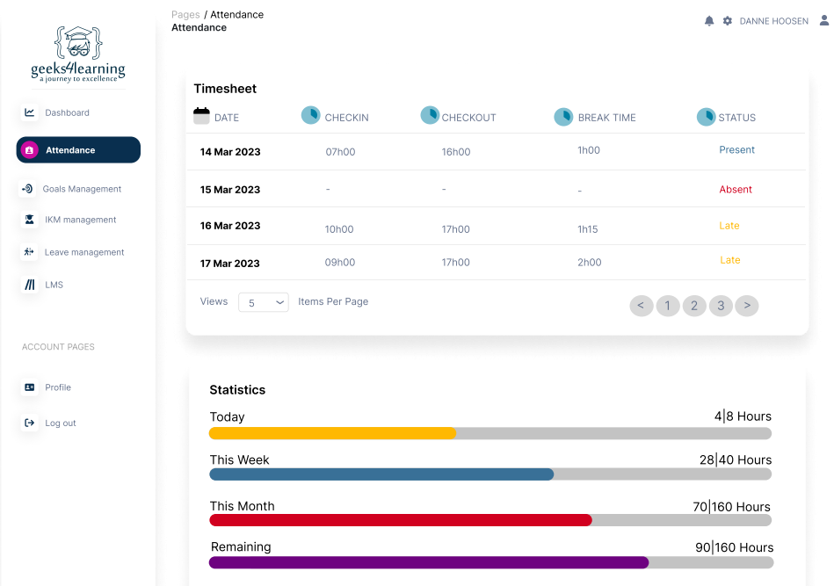

## **System Diagrams**

## **Use case Diagrams.**

The provided diagram illustrates the use case scenario for the Geeks4Learning Attendance System (LMS).

## **Activity Diagrams**

The provided activity diagrams comprehensively outline the dynamic flow of activities involving Geeks, Administrators, Super Administrators, and Trainers within the Attendance System.

* **Diagram for Super Admin**

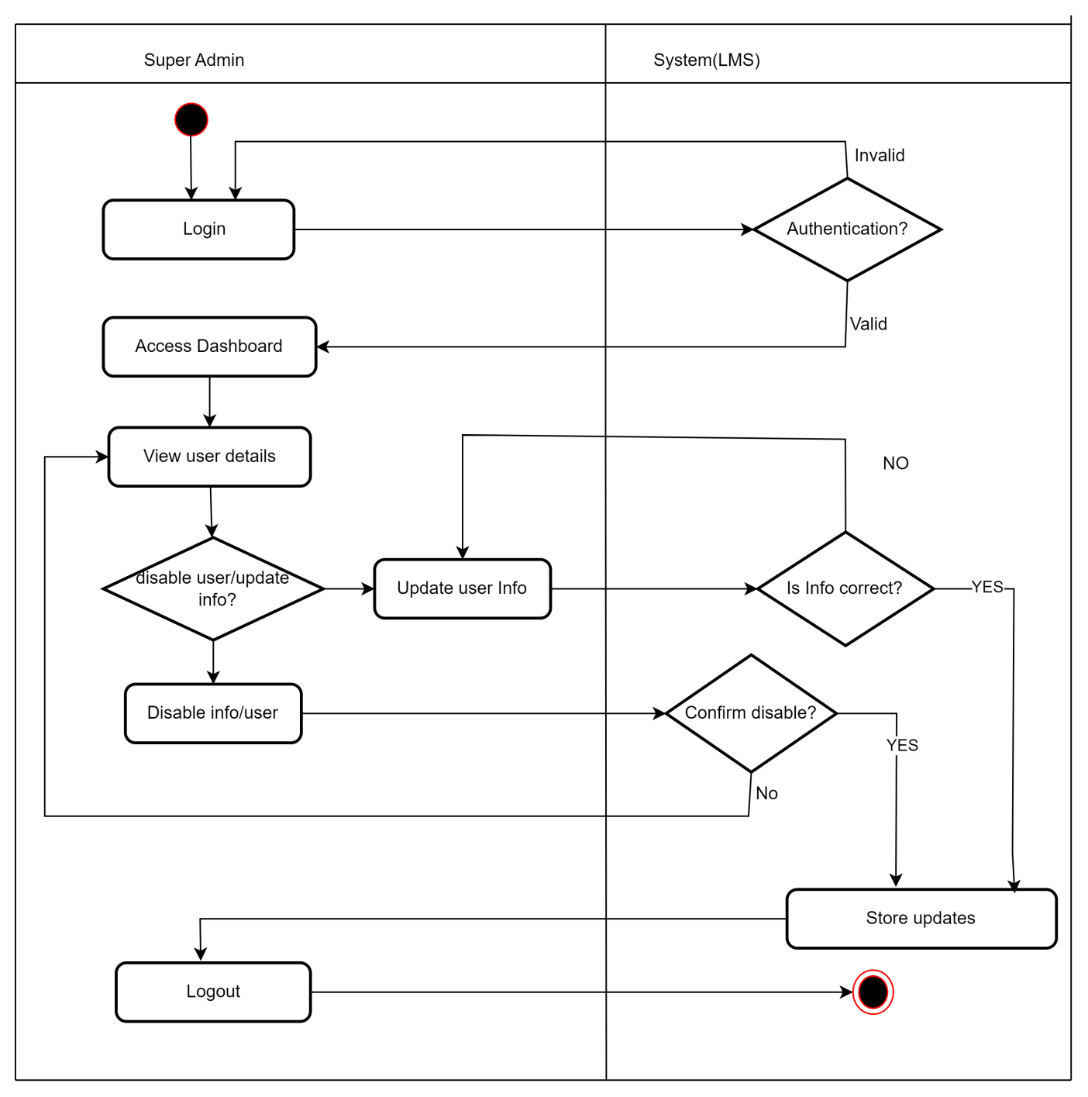

* **Diagram for Admin**

* **Diagram for Geek**

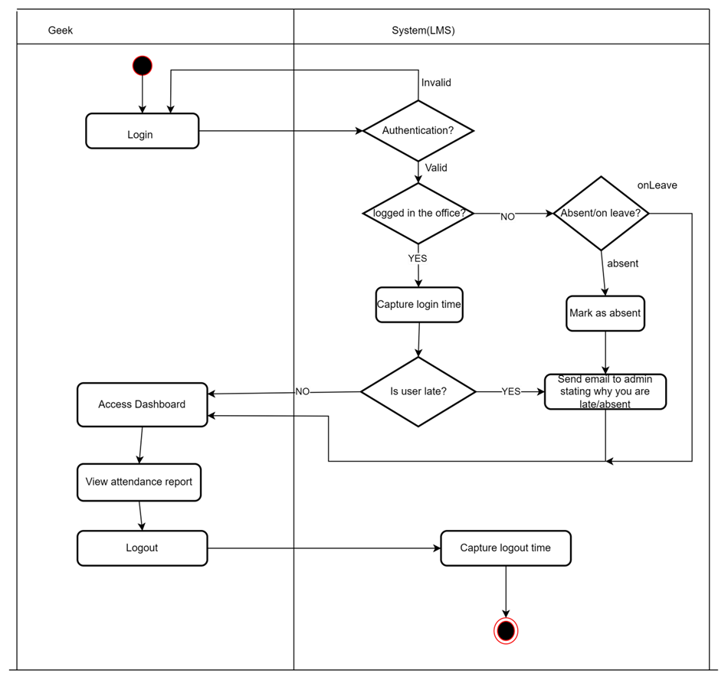

* **Diagram for Trainer**

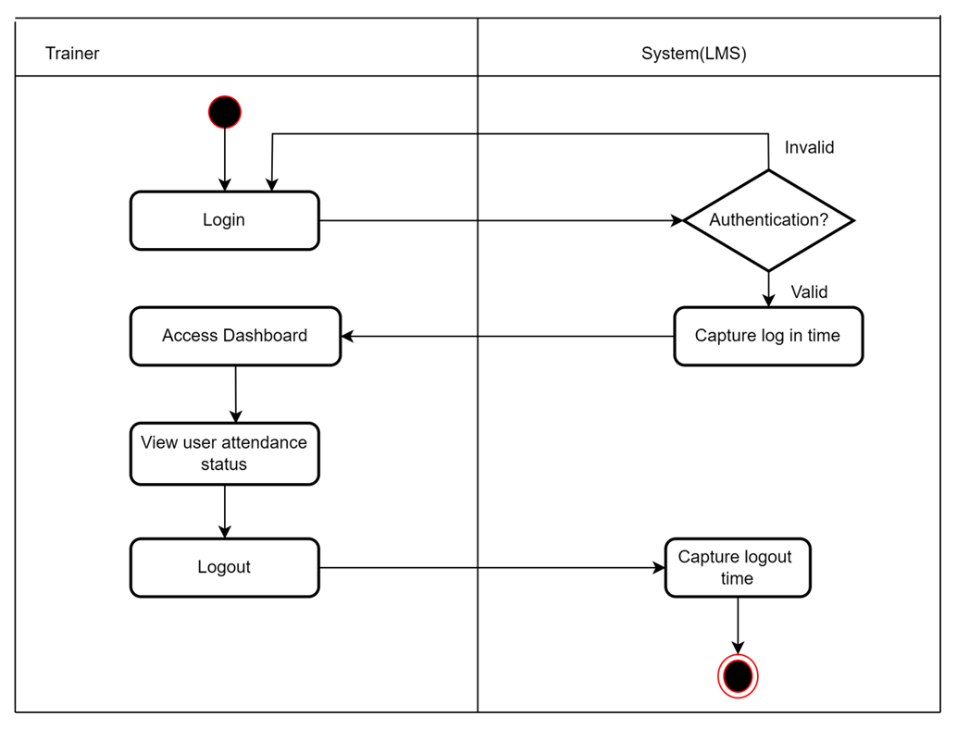

## **Class Diagrams**

The provided class diagram depicts the structural relationships and interactions between classes within the Attendance System.

**User**

userId:

-

String

+ getUserId() : String

**Attendance**

-

attendance_Id :

String

userId :

-

String

-

status

:

Enum

-

logInTime :

Time

logOutTime :

-

Time

-

date

:

Date

:

logInLocation

-

String

+

Getters

+

Setters

**Status**

-

status

:

e

num

setStatus() :

+

int

getStatus()

:

+

i

nt

## **Entity-Relationship Diagram**

The provided Entity-Relationship Diagram (ERD) illustrates the relationships and entities within the Attendance System's database structure.

